**Design Document for Children’s Game; Wizard’s Magical Treasures**

**Summary of the game:**

This is a multilevel game about a wizard catching different magical items in each level.

**Level 1**

His mission is to catch the magical fairies. He walks and when comes across to a fairy clicks the mouse to catch it. As soon as he catches the fairy, a cheering sound is made, and 1 point is added to his score. The score is calculated with the number of fairies caught; Level 1 is completed when 10 fairies are caught (score is 10)

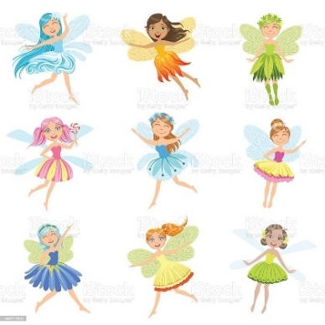

**Level 2**

His mission is to catch magical potions by clicking on them in the second level but has little monsters as obstructions this time. The wizard must jump over the little monsters (double click) to avoid hitting them. Each time he collects a potion a cheering sound is made, and 1 point is added to his score. Also, each time he hits a little monster, 1 point is decreased from his score. Level 2 is completed when 15 potions are caught (score is 15)

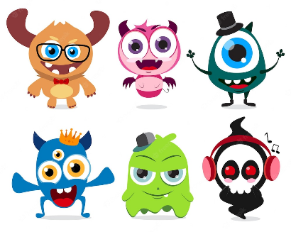

**Overview of project and Title**: The gamer(kids) walk on to find fairies and potions. The number of objects to find increases with each level.

The game is called Wizard’s Magical Treasures

**Key Stakeholders**: Children playing the game, the wizard, the fairies, the potions and the little monsters.

**Purpose of the Project and goals:** Entertain the kids whilst improving their multi-tasking skills and fine-motor skills with clicking function. Rewards(score) are given as they find fairies and potions.

**Proposed Solution:**

**Level 1**

|  |  |
| --- | --- |
| **Wizard** | **Fairy** |
| When the green flag is pressed (start the game) | When the green flag is pressed (start the game) |
| Forever walk and look for fairies | Forever wait |
| When you come across a fairy click to catch the fairy and get 1 point | When wizard catches you-Forever move forward a random position |
| When the cheering sound is made, continue walking to find more fairies | Forever wait |
| When you catch 10 fairies, Level 1 is completed, score is 10 | Stop |
| “Level completed” sign appears, click to move to Level 2 |  |

**Level 2**

|  |  |  |
| --- | --- | --- |
| **Wizard** | **Potion** | **Little Monster** |
| When the green flag is pressed (start the game) | When the green flag is pressed (start the game) | When the green flag is pressed (start the game) |
| Forever walk and look for potions | Forever wait | Forever wait |
| When you come across a potion click to catch the potion and get 1 point | Forever wait | Forever wait |
| When the cheering sound is made, continue searching for more potions | Forever move forward a random position | Forever wait |
| When you come across a little monster double click to jump to avoid touching | Forever wait | Forever move forward to a random position |
| If you touch a little monster lose 1 point | Forever wait | Forever move forward to a random position |
| When you catch 15 potions, Level 2 is completed, score is 15 | Stop | Stop |
| “Level completed” sign appears, click to move to Level 2 |  |  |

**Level 1**

**Wizard’s Flow Chart**

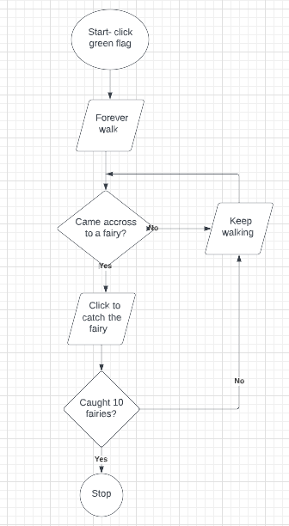

**Fairys’ Flow Chart**

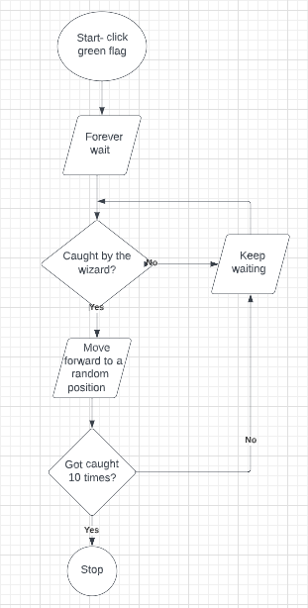

**Level 2**

**Wizard’s Flow Chart**

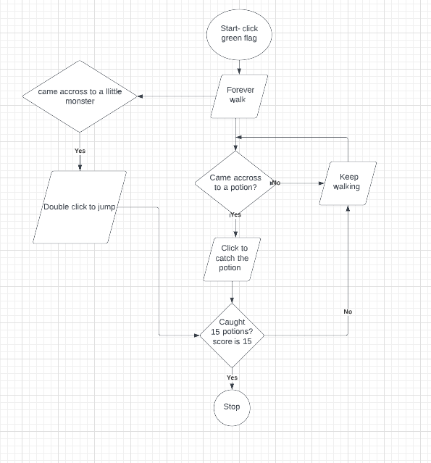

**Potions’ Flow Chart**

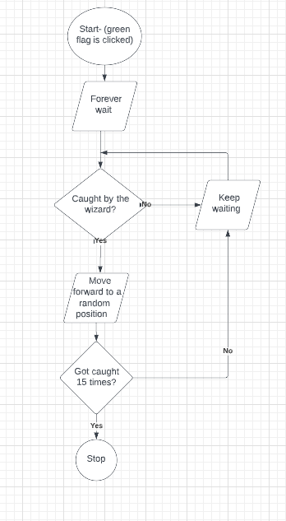

**Little Monsters’ Flow Chart**

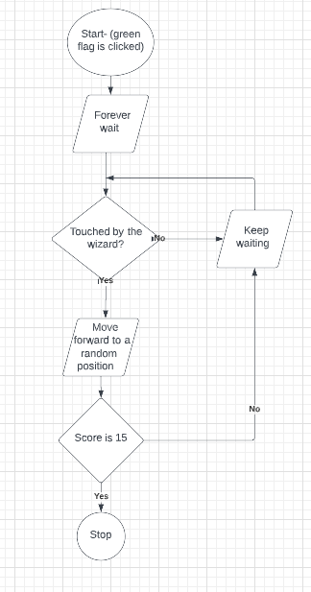

Gokce Gercek

Student No: 19141321